**Buck converter operation**

vi) Under the condition descript in v), the buck converter operate in continuous conduction mode. The conduction mode is determent by the average load current and the difference of current between on and off cycle – ΔI.

Average load current (Iload):

Iload = Vload / Rload

Vload = D x Vdc = 0.5 x 12 = 6V

Iload = 6/5 = 1.2A

The converter will operate in discontinuous conduction mode if ΔI/2 is greater than the load current. The ΔI can be calculated by:

ΔI = Vout (1 – D) T/L

T is the period of switching which is 20us. L is 50uH.

ΔI = 6 (1-0.5)(20x10^-6)/(50x10^-6) = 1.2A

Since ΔI/2 is 0.6A which is small the average load current, the converter operate in continuous conduction mode.

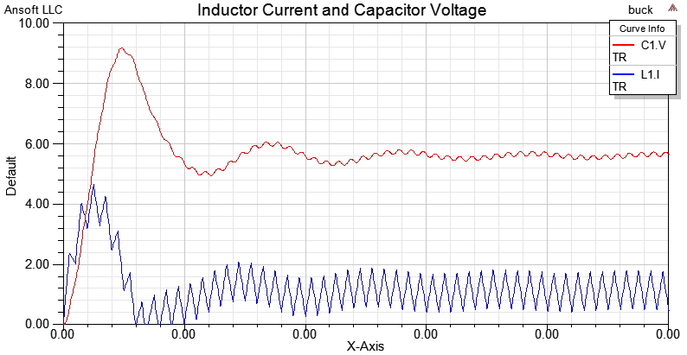

vii) The value of Vo is 6V under this operating condition which make sense because the Vo can be calculated by:

Vo = D x Vdc = 0.5 x 12 = 6V

vii) When the load current drop to 0.6A, the converter will operate at the borderline between CCM and DCM. It is because the ΔI is 1.2A at this condition. The load resistance can be calculating by:

Iload = Vload / Rload

0.6A = 6V / Rload

Rload = 10 ohms

Here is the result of simulation with initial condition Il = 0A, Vc = 0V and R = 10 ohms.

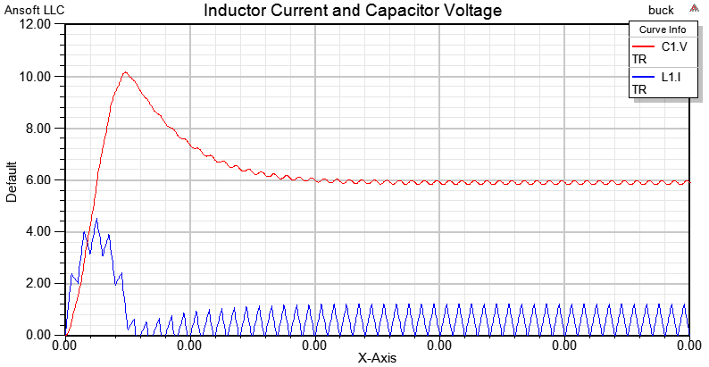

ix) With a load resistance of 5 ohms, the ΔI have to be 2.4A to force the converter operating on the borderline between CCM and DCM. The inductance value can be determined by:

ΔI = Vout (1 – D) T/L

L = Vout (1 – D) T/ΔI = 0.6 (1-0.5) (20x10^-6) / 2.4A = 25uH

Here is the result of simulation with initial condition Il = 0A, Vc = 0V and R = 5 ohms and L = 25uH.

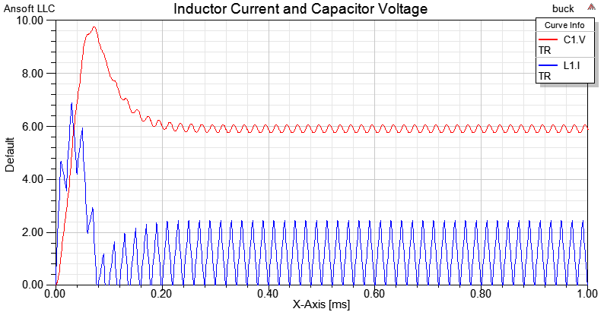

xi) Condition set as in part (vii) D = 0.2:

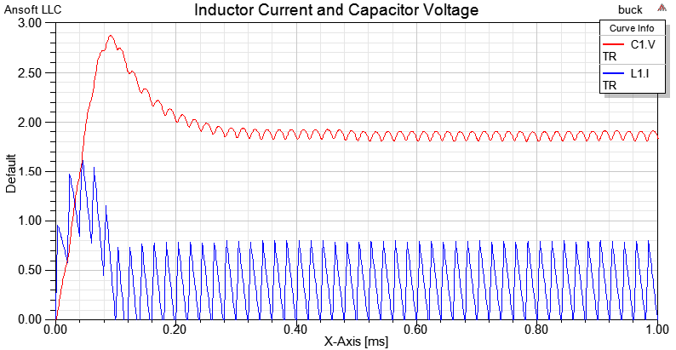

Condition set as in part (vii) D = 0.8:

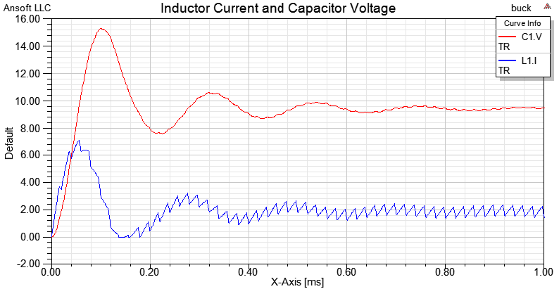

When we change the duty cycle of the converter, the voltage output varies with it. That is cause by the average voltage is determent by the on time and off time of the switch in a cycle – duty cycle. In an ideal case, the voltage output for a buck convertor with duty cycle of 0.8 and voltage input of 12V should be 9.6V, which is, confirm by the result above. The voltage output for duty cycle 0.2 and voltage input of 12V should be 2.4V. However, the result we got is lower than 2.4V. That is cause by the diode voltage drop. The effect of diode voltage drop would become less significance when the duty cycle increases.